SIMATS ENGINEERING
ASSESSMENT TOOL 1

COURSE NAME: INTERNET PROGRAMMING
COURSE CODE: CSA43

COURSE OUTCOME COVERED
CO-2 : Apply CSS layout and styling techniques to create visually appealing and responsive
web interfaces, and use JavaScript to enable interactive client-side behavior. (L3)
Assessment Tool : Integrated Experiments
Weightage: 40%

QUESTIONS: Total Marks: 30
Code of Conduct:
I KRITHI JS (192311262) certify that this submission is my
original work and that I have adhered to the guidelines specified for this assessment.
I understand that any violation of academic integrity rules will result in disciplinary
action.
Signature of the student:

Experiment 1: Responsive Layout Design
Suppose that a retail website is not responsive across mobile and tablet devices, causing
misalignment of content and improper spacing.
(a) Analyze the possible reasons for lack of responsiveness in the existing layout.
(b) Design a responsive webpage layout using CSS Flexbox or Grid, ensuring proper
alignment of header, navigation, content, and footer.
(c) Demonstrate how the layout adapts to different screen sizes (mobile, tablet, desktop)
using media queries.
(d) Implement spacing, alignment, and distribution techniques to improve visual consistency.
(e) Evaluate the effectiveness of the responsive design and suggest further improvements.

Experiment 2: Form Validation using JavaScript
Suppose that a registration form accepts invalid email and phone number inputs, leading to
incorrect data submission.
(a) Analyze the issues in the existing form validation mechanism.
(b) Design input fields for email and phone number with appropriate HTML attributes.
(c) Implement JavaScript validation using Regular Expressions for both email and phone
number.
(d) Develop a mechanism to display real-time error messages for invalid inputs.
(e) Evaluate the validation system and suggest enhancements for better user experience and
security.

Experiment 3: CSS Layout Debugging
Suppose that a webpage layout overlaps when the browser window is resized, affecting
usability.
(a) Analyze the CSS properties responsible for layout overlapping issues.
(b) Examine the role of the CSS box model (margin, border, padding, content) in layout
design.
(c) Debug the layout using appropriate positioning techniques (relative, absolute, flex,
grid).
(d) Modify the CSS to ensure proper alignment and prevent overlapping during resizing.
(e) Evaluate the corrected layout and suggest best practices for maintaining consistency.

EXPERIEMNT 1:
AIM
To design and develop a responsive retail website using HTML and CSS Flexbox/Grid with media queries to ensure proper alignment, spacing, and distribution of webpage elements across mobile, tablet, and desktop devices.
ANALYSIS
The existing retail website has layout issues such as misaligned content, improper spacing, fixed-width elements, and images overflowing their containers. These problems occur due to the lack of responsive design techniques and media queries. CSS Flexbox and Grid are used to arrange webpage elements systematically, while media queries adjust the layout according to different screen sizes. Proper margins, padding, gaps, and box-sizing properties improve visual consistency and usability.
CODE:

<!DOCTYPE html>
<html lang="en">
<head>
<meta charset="UTF-8">
<meta name="viewport" content="width=device-width, initial-scale=1.0">
<title>Nova | Modern Retail Store</title>

<style>
* {
margin: 0;
padding: 0;
box-sizing: border-box;
}

body {
font-family: Arial, sans-serif;
background: #f7f8fc;
color: #20243a;
}

header {
background: linear-gradient(120deg, #4435a5, #8066e9);
color: white;
padding: 25px 8%;
}

.topbar {
display: flex;
justify-content: space-between;
align-items: center;
gap: 15px;
}

.logo {
font-size: 30px;
font-weight: bold;
}

.cart {
background: white;
color: #4435a5;
padding: 10px 16px;
border-radius: 25px;
font-weight: bold;
}

nav {
display: flex;
flex-wrap: wrap;
gap: 25px;
padding-top: 22px;
}

nav a {
color: white;
text-decoration: none;
font-weight: bold;
}

nav a:hover {
color: #ffe082;
}

.hero {
padding: 45px 0 25px;
}

.hero h1 {
font-size: clamp(30px, 5vw, 48px);
margin-bottom: 12px;
}

.hero p {
line-height: 1.7;
}

.search {
width: 100%;
max-width: 450px;
padding: 13px;
margin-top: 20px;
border: none;
border-radius: 8px;
outline: none;
}

main {
max-width: 1200px;
margin: auto;
padding: 35px 20px;
}

.section-title {
margin-bottom: 8px;
font-size: 28px;
}

.subtitle {
color: #70758a;
margin-bottom: 25px;
}

.products {
display: grid;
grid-template-columns: repeat(3, minmax(0, 1fr));
gap: 24px;
}

.card {
background: white;
border-radius: 16px;
overflow: hidden;
box-shadow: 0 5px 20px #20243a10;
transition: transform 0.25s, box-shadow 0.25s;
}

.card:hover {
transform: translateY(-7px);
box-shadow: 0 12px 28px #20243a20;
}

.product-image {
height: 180px;
display: grid;
place-items: center;
font-size: 76px;
background: linear-gradient(135deg, #e9e5ff, #f8e9ff);
position: relative;
}

.card:nth-child(2) .product-image {
background: linear-gradient(135deg, #dff7f0, #e4efff);
}

.card:nth-child(3) .product-image {
background: linear-gradient(135deg, #fff0d9, #ffe2e9);
}

.badge {
position: absolute;
top: 12px;
left: 12px;
background: #ff647c;
color: white;
padding: 5px 10px;
border-radius: 20px;
font-size: 12px;
}

.details {
padding: 20px;
}

.details h3 {
margin-bottom: 8px;
}

.description {
color: #73778b;
font-size: 14px;
margin-bottom: 15px;
}

.price {
color: #4435a5;
font-size: 21px;
font-weight: bold;
margin-bottom: 15px;
}

button {
width: 100%;
padding: 12px;
background: #5141bc;
color: white;
border: none;
border-radius: 8px;
font-weight: bold;
cursor: pointer;
}

button:hover {
background: #33258f;
}

.empty {
display: none;
text-align: center;
padding: 30px;
color: #73778b;
}

footer {
text-align: center;
background: #20243a;
color: white;
padding: 22px;
margin-top: 20px;
}

@media (max-width: 800px) {
.products {
grid-template-columns: repeat(2, minmax(0, 1fr));
}

header {
padding: 22px 5%;
}
}

@media (max-width: 520px) {
.products {
grid-template-columns: 1fr;
}

.topbar {
align-items: flex-start;
flex-direction: column;
}

nav {
gap: 15px;
}

.product-image {
height: 160px;
}
}
</style>
</head>

<body>

<header>
<div class="topbar">
<div class="logo">✦ NOVA</div>
<div class="cart">🛒 Cart: <span id="cartCount">0</span></div>
</div>

<nav>
<a href="#home">Home</a>
<a href="#products">Products</a>
<a href="#offers">Offers</a>
<a href="#contact">Contact</a>
</nav>

<section class="hero" id="home">
<h1>Discover Your Style.</h1>
<p>Beautiful products. Great prices. A better shopping experience.</p>
<input class="search" type="search" id="search"
placeholder="🔍 Search products...">
</section>
</header>

<main id="products">
<h2 class="section-title">Featured Collection ✨</h2>
<p class="subtitle" id="offers">Handpicked favourites just for you.</p>

<section class="products" id="productList">

<article class="card" data-name="headphones wireless audio">
<div class="product-image">
<span class="badge">BESTSELLER</span>
🎧
</div>
<div class="details">
<h3>Wireless Headphones</h3>
<p class="description">Immersive sound, everyday comfort.</p>
<p class="price">₹1,499</p>
<button class="add">Add to Cart +</button>
</div>
</article>

<article class="card" data-name="smart watch fitness technology">
<div class="product-image">
<span class="badge">NEW</span>
⌚
</div>
<div class="details">
<h3>Smart Watch</h3>
<p class="description">Smart features for your daily life.</p>
<p class="price">₹2,299</p>
<button class="add">Add to Cart +</button>
</div>
</article>

<article class="card" data-name="backpack travel bag">
<div class="product-image">
<span class="badge">20% OFF</span>
🎒
</div>
<div class="details">
<h3>Everyday Backpack</h3>
<p class="description">Carry your essentials in style.</p>
<p class="price">₹999</p>
<button class="add">Add to Cart +</button>
</div>
</article>

</section>

<p class="empty" id="emptyMessage">No matching products found.</p>
</main>

<footer id="contact">
<p>✦ NOVA Retail Store | Designed for everyone, everywhere.</p>
</footer>

<script>
let cartCount = 0;

document.querySelectorAll(".add").forEach(function(button) {
button.addEventListener("click", function() {
cartCount++;
document.getElementById("cartCount").textContent = cartCount;

button.textContent = "✓ Added!";
setTimeout(function() {
button.textContent = "Add to Cart +";
}, 900);
});
});

document.getElementById("search").addEventListener("input", function() {
const query = this.value.toLowerCase().trim();
let visibleCount = 0;

document.querySelectorAll(".card").forEach(function(card) {
const matches = card.dataset.name.includes(query);
card.style.display = matches ? "" : "none";

if (matches) visibleCount++;
});

document.getElementById("emptyMessage").style.display =
visibleCount === 0 ? "block" : "none";
});
</script>

</body>
</html>
OUTPUT:
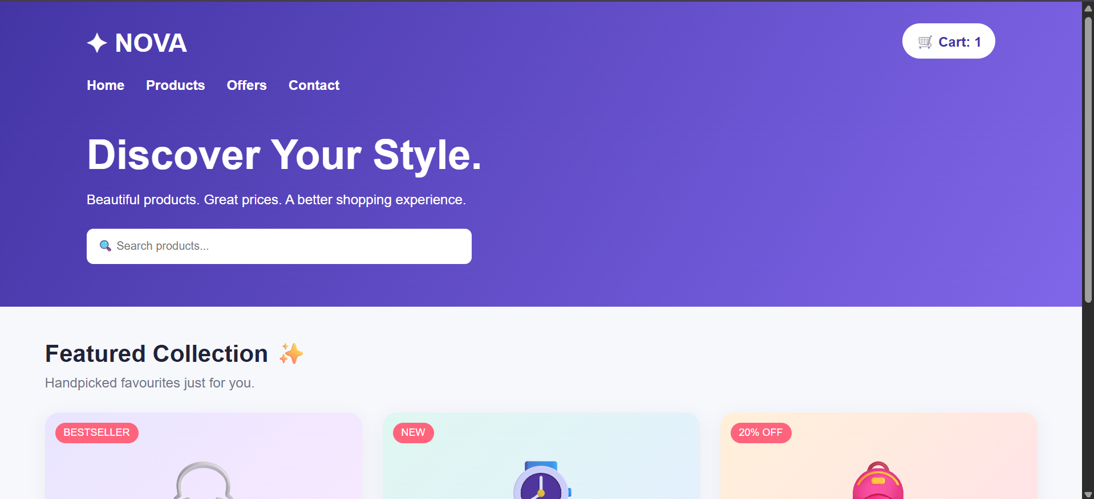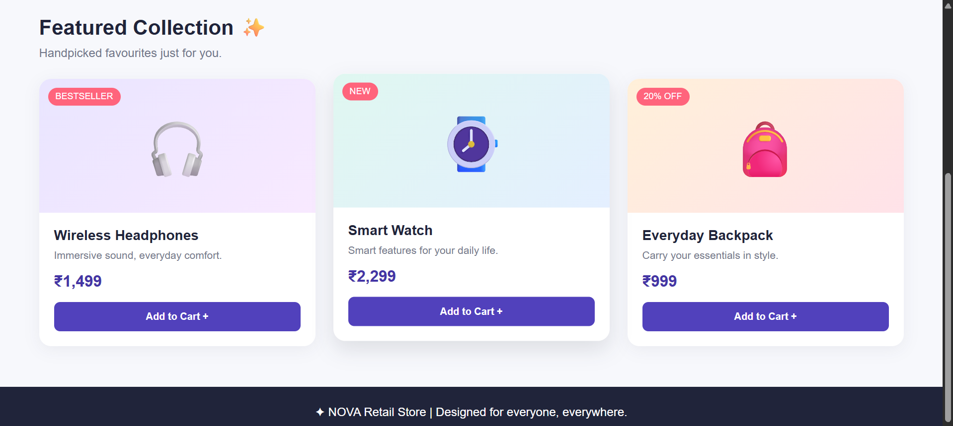
RESULT A responsive retail website was developed successfully using HTML and CSS, providing proper alignment, consistent spacing, and an improved user experience across mobile, tablet, and desktop devices.

EXPERIEMNT 2:
AIM
To design and develop a registration form using HTML, CSS, and JavaScript to validate email addresses and phone numbers using regular expressions and display real-time error messages for invalid inputs.
ANALYSIS
The existing registration form accepts invalid email addresses and phone numbers due to insufficient validation mechanisms. This may lead to incorrect data submission and reduced data accuracy. HTML input attributes and JavaScript regular expressions are used to validate user inputs. Real-time validation displays error messages while users enter their details, helping them identify and correct mistakes before submission. Additional checks ensure that required fields contain valid inputs.
CODE:

<!DOCTYPE html>
<html lang="en">
<head>
<meta charset="UTF-8">
<meta name="viewport" content="width=device-width, initial-scale=1.0">
<title>Create Your Account</title>

<style>
* {
box-sizing: border-box;
}

body {
margin: 0;
min-height: 100vh;
display: flex;
justify-content: center;
align-items: center;
padding: 20px;
font-family: Arial, sans-serif;
background: linear-gradient(135deg, #d8d5ff, #fce1ee, #d7f4f0);
}

.form-card {
width: 100%;
max-width: 430px;
background: white;
padding: 32px;
border-radius: 20px;
box-shadow: 0 15px 45px #35305a20;
}

.icon {
width: 60px;
height: 60px;
display: grid;
place-items: center;
margin: 0 auto 15px;
border-radius: 18px;
background: #ece8ff;
font-size: 30px;
}

h1 {
text-align: center;
margin-bottom: 8px;
color: #30275d;
}

.intro {
text-align: center;
color: #77758b;
margin-bottom: 25px;
line-height: 1.5;
}

.field {
margin-bottom: 18px;
}

label {
display: block;
margin-bottom: 7px;
font-weight: bold;
color: #38364d;
}

input {
width: 100%;
padding: 13px;
border: 1.5px solid #deddea;
border-radius: 9px;
outline: none;
font-size: 15px;
transition: border-color 0.2s, box-shadow 0.2s;
}

input:focus {
border-color: #6955d4;
box-shadow: 0 0 0 3px #6955d420;
}

input.invalid {
border-color: #dc3545;
}

input.valid {
border-color: #198754;
}

.error {
color: #c62828;
font-size: 13px;
margin: 6px 0 0;
min-height: 15px;
}

.password-row {
display: flex;
gap: 8px;
}

.password-row input {
flex: 1;
min-width: 0;
}

.toggle {
width: auto;
padding: 0 12px;
border: 1px solid #deddea;
border-radius: 9px;
background: #f5f3ff;
cursor: pointer;
}

.submit-btn {
width: 100%;
padding: 14px;
background: linear-gradient(90deg, #5141bc, #8268e8);
color: white;
border: none;
border-radius: 9px;
font-size: 16px;
font-weight: bold;
cursor: pointer;
transition: transform 0.2s;
}

.submit-btn:hover {
transform: translateY(-2px);
}

#result {
margin-top: 16px;
text-align: center;
line-height: 1.5;
}

.success {
color: #147747;
background: #e6f7ee;
border-radius: 8px;
padding: 12px;
}

.failure {
color: #b42332;
}

.note {
color: #77758b;
font-size: 12px;
margin-top: 18px;
text-align: center;
}

@media (max-width: 400px) {
.form-card {
padding: 22px;
}
}
</style>
</head>

<body>

<main class="form-card">
<div class="icon">✦</div>
<h1>Create Account</h1>
<p class="intro">Join us today. Enter your details below.</p>

<form id="registerForm" novalidate>

<div class="field">
<label for="name">Full Name</label>
<input type="text" id="name" autocomplete="name"
placeholder="Enter your name" required>
<p class="error" id="nameError"></p>
</div>

<div class="field">
<label for="email">Email Address</label>
<input type="email" id="email" autocomplete="email"
placeholder="you@example.com" required>
<p class="error" id="emailError"></p>
</div>

<div class="field">
<label for="phone">Mobile Number</label>
<input type="tel" id="phone" inputmode="numeric"
autocomplete="tel" maxlength="10"
placeholder="10-digit mobile number" required>
<p class="error" id="phoneError"></p>
</div>

<div class="field">
<label for="password">Password</label>
<div class="password-row">
<input type="password" id="password"
autocomplete="new-password"
placeholder="At least 8 characters" required>
<button type="button" class="toggle" id="togglePassword"
aria-label="Show password">Show</button>
</div>
<p class="error" id="passwordError"></p>
</div>

<button type="submit" class="submit-btn">
Create My Account →
</button>

<p id="result" role="status" aria-live="polite"></p>
</form>

<p class="note">Your details are checked before submission.</p>
</main>

<script>
const form = document.getElementById("registerForm");
const nameInput = document.getElementById("name");
const emailInput = document.getElementById("email");
const phoneInput = document.getElementById("phone");
const passwordInput = document.getElementById("password");
const result = document.getElementById("result");

function setError(input, errorId, message) {
document.getElementById(errorId).textContent = message;
input.classList.toggle("invalid", message !== "");
input.classList.toggle("valid", message === "" && input.value.trim() !== "");
}

function validateName() {
const value = nameInput.value.trim();
const valid = value.length >= 2;

setError(nameInput, "nameError",
valid ? "" : "Please enter at least 2 characters.");
return valid;
}

function validateEmail() {
const pattern = /^[^\s@]+@[^\s@]+\.[^\s@]+$/;
const valid = pattern.test(emailInput.value.trim());

setError(emailInput, "emailError",
valid ? "" : "Please enter a valid email address.");
return valid;
}

function validatePhone() {
const pattern = /^[6-9]\d{9}$/;
const valid = pattern.test(phoneInput.value.trim());

setError(phoneInput, "phoneError",
valid ? "" : "Enter a valid 10-digit Indian mobile number.");
return valid;
}

function validatePassword() {
const value = passwordInput.value;
const valid = value.length >= 8;

setError(passwordInput, "passwordError",
valid ? "" : "Password must contain at least 8 characters.");
return valid;
}

nameInput.addEventListener("input", validateName);
emailInput.addEventListener("input", validateEmail);
phoneInput.addEventListener("input", validatePhone);
passwordInput.addEventListener("input", validatePassword);

document.getElementById("togglePassword").addEventListener("click", function() {
const show = passwordInput.type === "password";
passwordInput.type = show ? "text" : "password";
this.textContent = show ? "Hide" : "Show";
this.setAttribute("aria-label", show ? "Hide password" : "Show password");
});

form.addEventListener("submit", function(event) {
event.preventDefault();

const nameValid = validateName();
const emailValid = validateEmail();
const phoneValid = validatePhone();
const passwordValid = validatePassword();

if (nameValid && emailValid && phoneValid && passwordValid) {
result.textContent =
"✓ All fields are valid! Registration demo completed.";
result.className = "success";
} else {
result.textContent = "Please correct the highlighted fields.";
result.className = "failure";

if (!nameValid) nameInput.focus();
else if (!emailValid) emailInput.focus();
else if (!phoneValid) phoneInput.focus();
else passwordInput.focus();
}
});
</script>

</body>
</html>
OUTPUT:
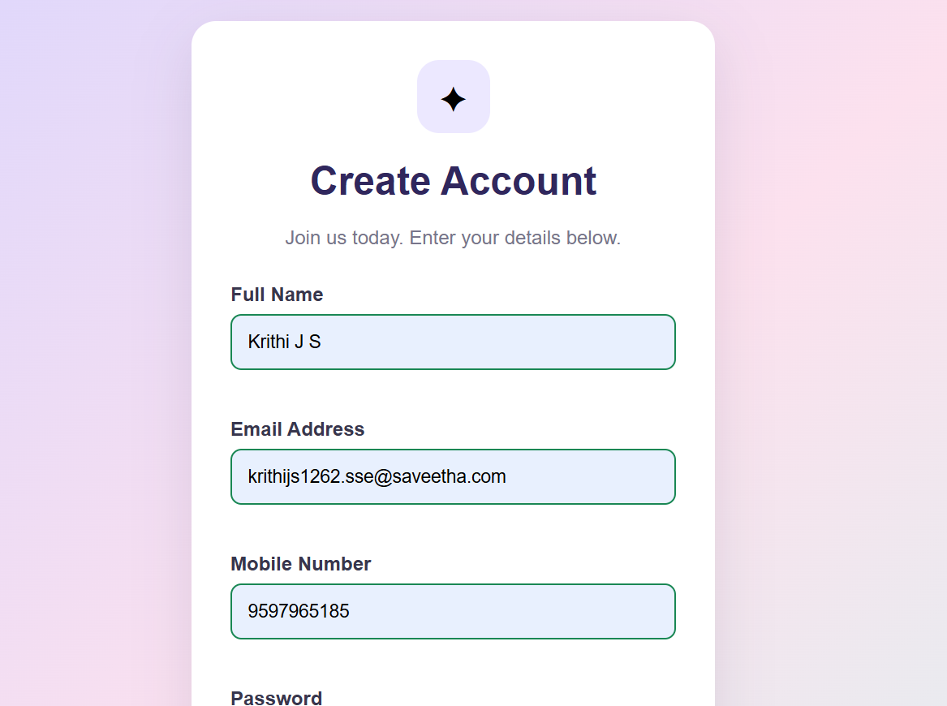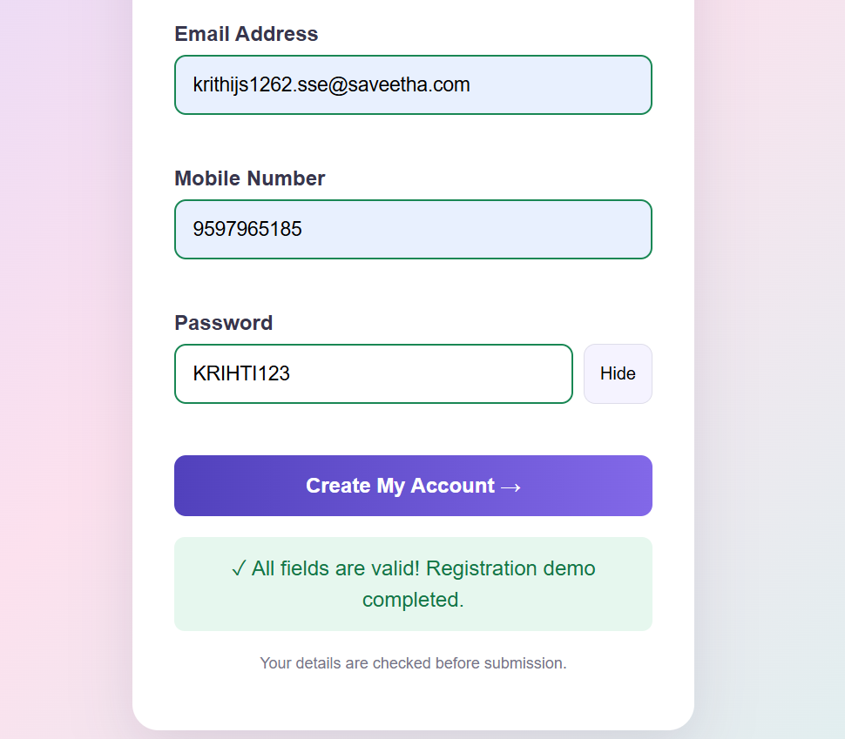

RESULT
A registration form with real-time email and phone number validation was implemented successfully using HTML, CSS, and JavaScript, improving data accuracy and user experience.

EXPERIMENT 3:
AIM
To identify and correct webpage layout overlapping issues using the CSS box model, positioning techniques, Flexbox, Grid, and media queries to maintain proper alignment and prevent overlapping during browser resizing.
ANALYSIS
Webpage overlapping issues may occur due to fixed dimensions, incorrect positioning, excessive margins and padding, and improper use of the CSS box model. The box model consists of content, padding, border, and margin, which determine the size and spacing of webpage elements. CSS Grid and Flexbox help organize content and maintain consistent alignment. The box-sizing: border-box property and responsive media queries prevent unexpected sizing issues and allow the layout to adapt to different screen sizes.
CODE:

<!DOCTYPE html>
<html lang="en">
<head>
<meta charset="UTF-8">
<meta name="viewport" content="width=device-width, initial-scale=1.0">
<title>CSS Layout Debugging Dashboard</title>

<style>
/* Reset and Box Model */
* {
margin: 0;
padding: 0;
box-sizing: border-box;
}

body {
font-family: Arial, sans-serif;
background-color: #f3f5fa;
color: #252a41;
line-height: 1.6;
}

/* Header */
header {
display: flex;
justify-content: space-between;
align-items: center;
flex-wrap: wrap;
gap: 15px;
padding: 20px 30px;
background: linear-gradient(120deg, #29265b, #6654c8);
color: white;
}

.logo {
font-size: 25px;
font-weight: bold;
}

.menu-button {
padding: 10px 16px;
border: 1px solid #ffffff70;
border-radius: 8px;
background: #ffffff20;
color: white;
cursor: pointer;
}

.menu-button:hover {
background: #ffffff35;
}

/* Main Layout */
.layout {
display: grid;
grid-template-columns: 230px minmax(0, 1fr);
min-height: calc(100vh - 80px);
}

/* Sidebar */
.sidebar {
background-color: white;
padding: 25px 15px;
border-right: 1px solid #e0e3ed;
}

.sidebar h3 {
color: #777d92;
font-size: 14px;
margin: 10px;
}

.sidebar a {
display: block;
padding: 12px;
margin-bottom: 8px;
border-radius: 8px;
color: #41465e;
text-decoration: none;
}

.sidebar a:hover,
.sidebar a.active {
background-color: #efedff;
color: #5141bc;
}

/* Main Content */
main {
min-width: 0;
padding: 30px;
}

.welcome {
display: flex;
justify-content: space-between;
align-items: center;
flex-wrap: wrap;
gap: 15px;
margin-bottom: 25px;
}

.welcome h1 {
font-size: clamp(24px, 3vw, 32px);
margin-bottom: 5px;
}

.welcome p {
color: #777d92;
}

.date {
padding: 10px 15px;
background-color: white;
border: 1px solid #e0e3ed;
border-radius: 8px;
}

/* Dashboard Cards */
.cards {
display: grid;
grid-template-columns: repeat(3, minmax(0, 1fr));
gap: 20px;
margin-bottom: 25px;
}

.card {
min-width: 0;
padding: 22px;
background-color: white;
border-radius: 14px;
border: 1px solid #e5e7f0;
box-shadow: 0 4px 15px #252a4108;
transition: transform 0.2s, box-shadow 0.2s;
}

.card:hover {
transform: translateY(-4px);
box-shadow: 0 8px 20px #252a4115;
}

.card .icon {
font-size: 30px;
margin-bottom: 10px;
}

.card p {
color: #777d92;
font-size: 14px;
overflow-wrap: anywhere;
}

.card h2 {
font-size: 30px;
margin: 8px 0;
overflow-wrap: anywhere;
}

.purple {
border-top: 4px solid #7765e8;
}

.green {
border-top: 4px solid #26b887;
}

.orange {
border-top: 4px solid #ffad52;
}

/* Content Sections */
.content-grid {
display: grid;
grid-template-columns: minmax(0, 1.5fr) minmax(0, 1fr);
gap: 20px;
}

.panel {
min-width: 0;
padding: 24px;
background-color: white;
border: 1px solid #e5e7f0;
border-radius: 14px;
}

.panel h2 {
font-size: 20px;
margin-bottom: 18px;
}

.activity {
display: flex;
align-items: flex-start;
gap: 12px;
padding: 15px 0;
border-bottom: 1px solid #eeeeF5;
}

.activity:last-child {
border-bottom: none;
}

.activity-icon {
display: grid;
place-items: center;
width: 42px;
height: 42px;
flex-shrink: 0;
border-radius: 10px;
background-color: #efedff;
}

.activity-details {
min-width: 0;
}

.activity-details h3 {
font-size: 15px;
overflow-wrap: anywhere;
}

.activity-details p {
color: #777d92;
font-size: 13px;
}

/* Progress Bar */
.progress {
height: 10px;
margin: 20px 0 10px;
overflow: hidden;
background-color: #eeeeF5;
border-radius: 10px;
}

.progress-bar {
width: 75%;
height: 100%;
background: linear-gradient(90deg, #6956d7, #a18cf8);
border-radius: 10px;
}

.progress-info {
display: flex;
justify-content: space-between;
flex-wrap: wrap;
gap: 8px;
color: #777d92;
font-size: 13px;
}

/* Footer */
footer {
padding: 18px;
text-align: center;
color: #777d92;
background-color: white;
border-top: 1px solid #e5e7f0;
}

/* Collapsed Sidebar */
.layout.collapsed {
grid-template-columns: minmax(0, 1fr);
}

.layout.collapsed .sidebar {
display: none;
}

/* Tablet */
@media screen and (max-width: 900px) {
.cards {
grid-template-columns: repeat(2, minmax(0, 1fr));
}

.content-grid {
grid-template-columns: minmax(0, 1fr);
}

main {
padding: 20px;
}
}

/* Mobile */
@media screen and (max-width: 600px) {
header {
padding: 16px;
}

.logo {
font-size: 21px;
}

.layout {
grid-template-columns: minmax(0, 1fr);
}

.sidebar {
border-right: none;
border-bottom: 1px solid #e0e3ed;
}

.cards {
grid-template-columns: minmax(0, 1fr);
gap: 14px;
}

main {
padding: 15px;
}

.panel {
padding: 17px;
}

.welcome h1 {
font-size: 25px;
}
}
</style>
</head>

<body>

<!-- Header -->
<header>
<div class="logo">✦ FlexSpace Dashboard</div>

<button class="menu-button"
id="menuButton"
aria-expanded="true"
aria-controls="sidebar">
☰ Toggle Menu
</button>
</header>

<!-- Responsive Layout -->
<div class="layout" id="layout">

<!-- Sidebar -->
<aside class="sidebar" id="sidebar">
<h3>MAIN MENU</h3>

<a href="#dashboard" class="active">▦ Dashboard</a>
<a href="#projects">📁 Projects</a>
<a href="#activities">✓ Activities</a>
<a href="#progress">◷ Progress</a>
</aside>

<!-- Main Content -->
<main id="dashboard">

<section class="welcome">
<div>
<h1>Welcome Back! 👋</h1>
<p>Manage your projects and activities in one place.</p>
</div>

<div class="date">✨ Workspace Overview</div>
</section>

<!-- Dashboard Cards -->
<section class="cards" id="projects">

<article class="card purple">
<div class="icon">📁</div>
<p>Total Projects</p>
<h2>24</h2>
<p>Your active projects</p>
</article>

<article class="card green">
<div class="icon">✅</div>
<p>Completed Tasks</p>
<h2>86</h2>
<p>Successfully completed</p>
</article>

<article class="card orange">
<div class="icon">⏳</div>
<p>Pending Tasks</p>
<h2>12</h2>
<p>Tasks awaiting completion</p>
</article>

</section>

<!-- Activities and Progress -->
<section class="content-grid">

<article class="panel" id="activities">
<h2>Recent Activities</h2>

<div class="activity">
<div class="activity-icon">🎨</div>
<div class="activity-details">
<h3>Website Design</h3>
<p>Responsive interface updated successfully.</p>
</div>
</div>

<div class="activity">
<div class="activity-icon">💻</div>
<div class="activity-details">
<h3>Development</h3>
<p>Dashboard layout improvements completed.</p>
</div>
</div>

<div class="activity">
<div class="activity-icon">📱</div>
<div class="activity-details">
<h3>Mobile Optimization</h3>
<p>Layout adjusted for smaller screens.</p>
</div>
</div>
</article>

<article class="panel" id="progress">
<h2>Project Progress</h2>
<p>Overall project completion</p>

<div class="progress">
<div class="progress-bar"></div>
</div>

<div class="progress-info">
<span>75% Completed</span>
<span>On Track</span>
</div>
</article>

</section>

</main>
</div>

<!-- Footer -->
<footer>
<p>FlexSpace Dashboard | Responsive CSS Layout</p>
</footer>

<!-- JavaScript -->
<script>
const layout = document.getElementById("layout");
const menuButton = document.getElementById("menuButton");

menuButton.addEventListener("click", function () {
layout.classList.toggle("collapsed");

const collapsed = layout.classList.contains("collapsed");

menuButton.setAttribute(
"aria-expanded",
String(!collapsed)
);

menuButton.textContent = collapsed
? "☰ Show Menu"
: "☰ Toggle Menu";
});
</script>

</body>
</html>
OUTPUT:
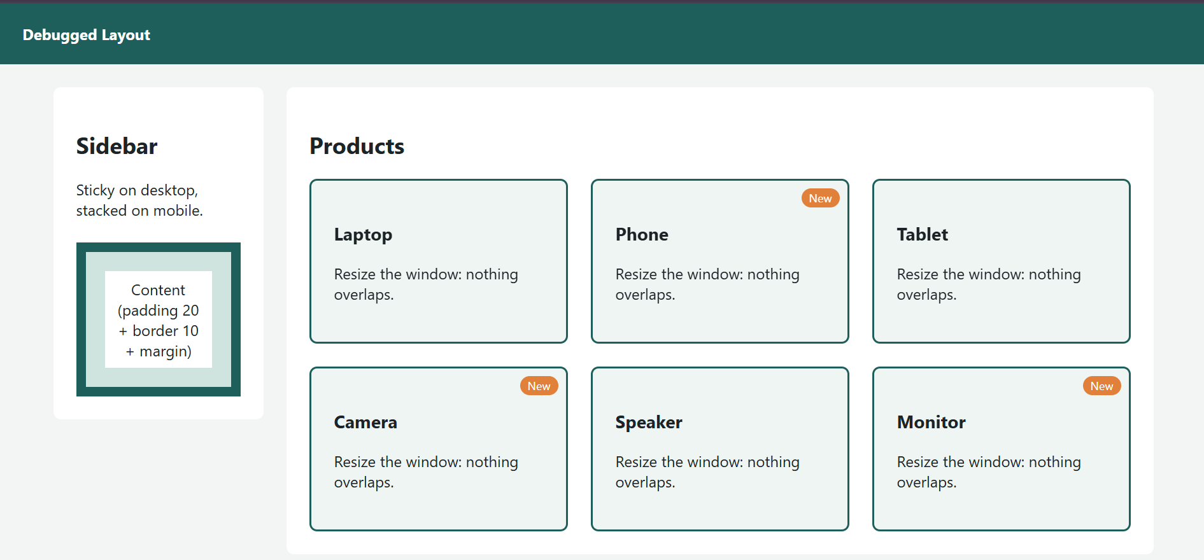
RESULT
The webpage layout was corrected successfully using CSS Grid, Flexbox, box-model properties, and media queries, ensuring proper alignment, consistent spacing, and reduced overlapping across different screen sizes.

